

Install, Configure Couchbase EDSI Plugin for Delphix Engine

Ajay Thotangare

Technical Manager, Technical Services

|  |  |  |  |
| --- | --- | --- | --- |
| **Revision** | **Issue Date** | **Originator** | **Comment** |
| 0.0.1 | Apr 04,2020 | Ajay Thotangare | Initial Draft |
| 0.0.2 | Apr 25,2020 | Ajay Thotangare |  |
|  |  |  |  |
|  |  |  |  |
|  |  |  |  |
|  |  |  |  |
|  |  |  |  |
|  |  |  |  |

# Table of Contents

Table of Contents 3

Purpose 4

Audience 4

Prerequisites 4

Install Couchbase EDSI Plugin 4

Refresh Environment 7

Create Sourceconfig 8

Create dSource 9

XDCR Method 9

Couchbase Backup Manager Method 13

Provision VDB 14

Appendix 15

Known Issues 15

Simultaneous dSource creation 15

# Purpose

This document will help to install configure couchbase edsi

1. …..
2. …..
3. …..

# Audience

* Delphix Administrators
* Solution / Technical Architects

# Prerequisites

* Install delphix engine 5.3.x and above
* Install couchbase binaries on source and target servers

# Install Couchbase EDSI Plugin

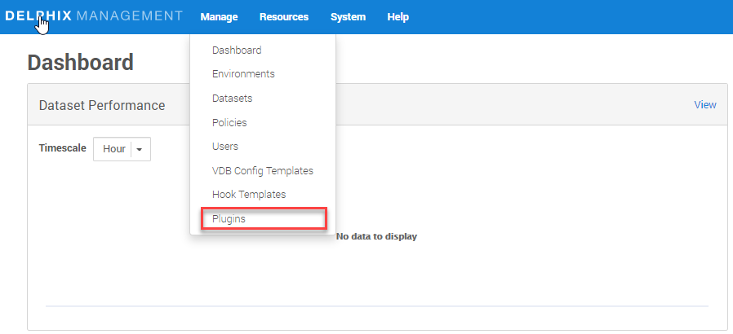

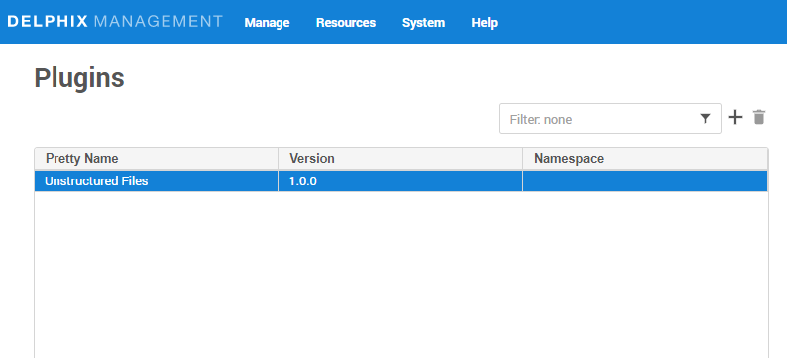

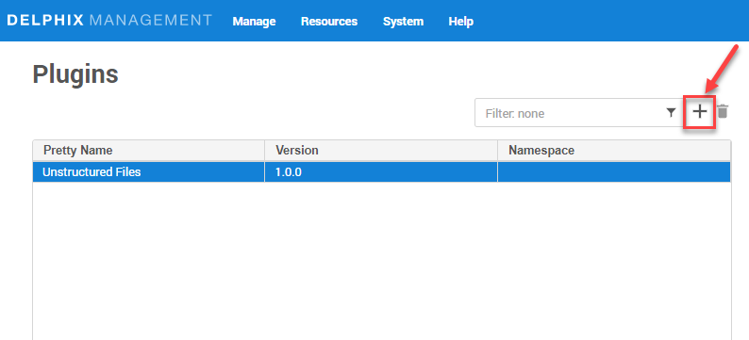

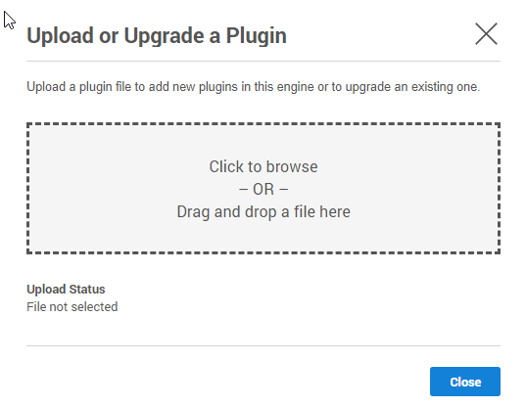

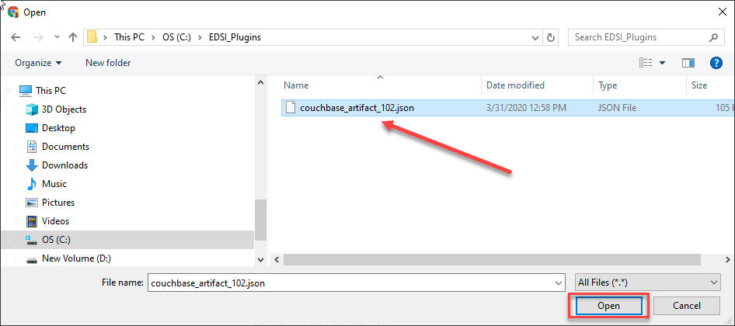

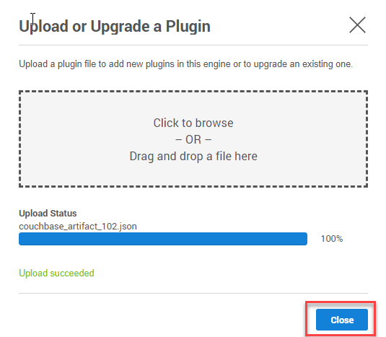

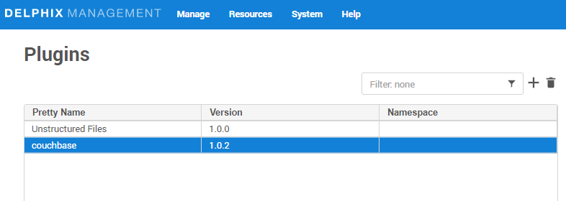

# Refresh Environment

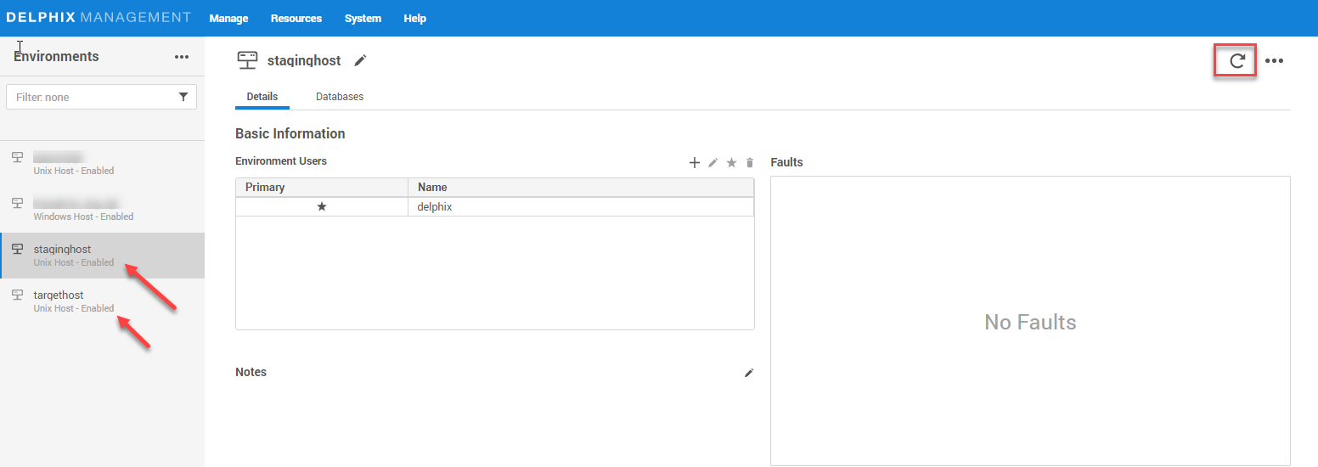

# Create Sourceconfig

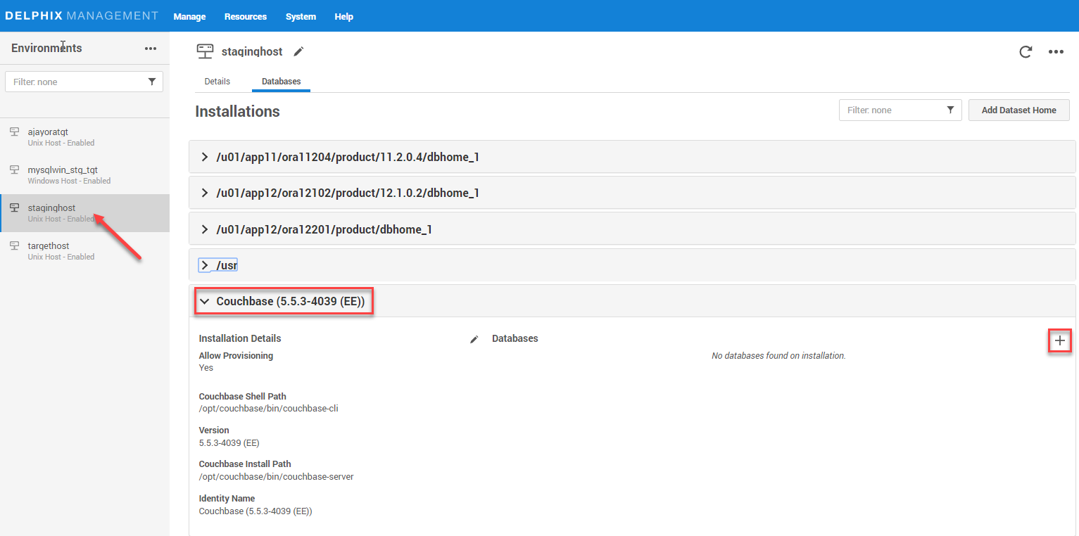

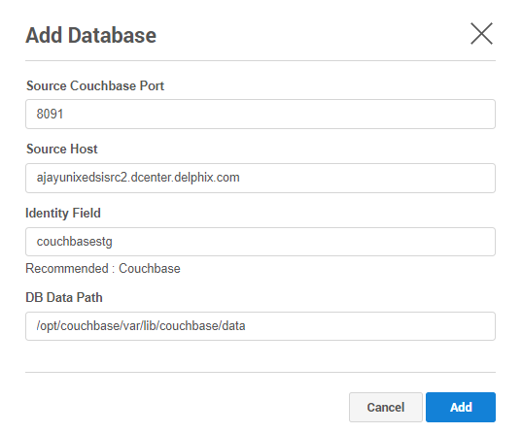

# Create dSource

## XDCR Method

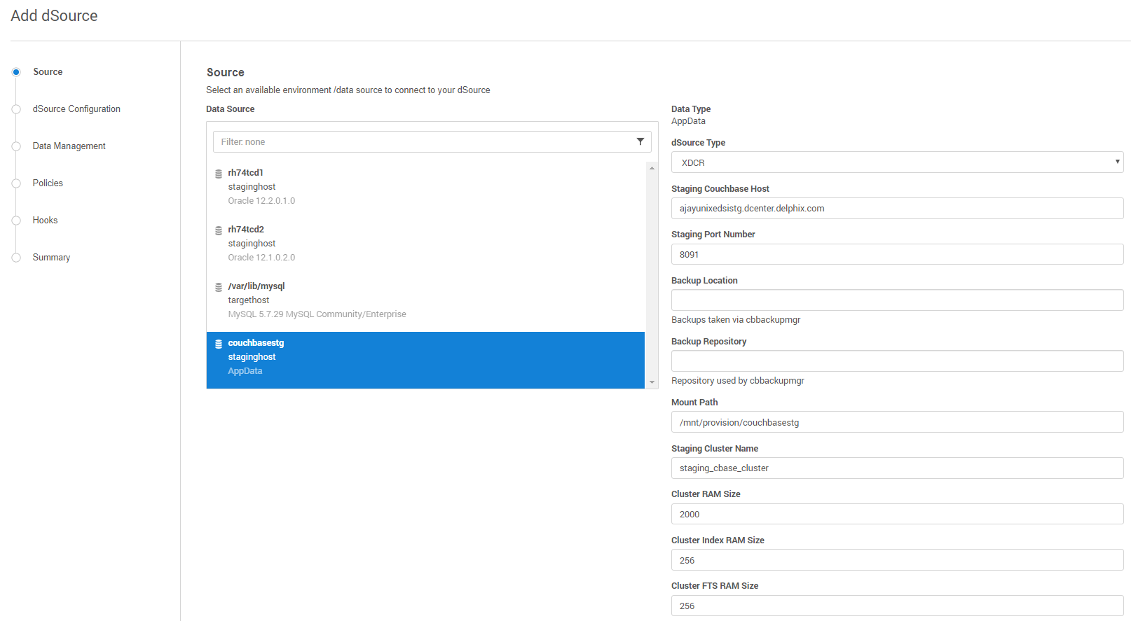

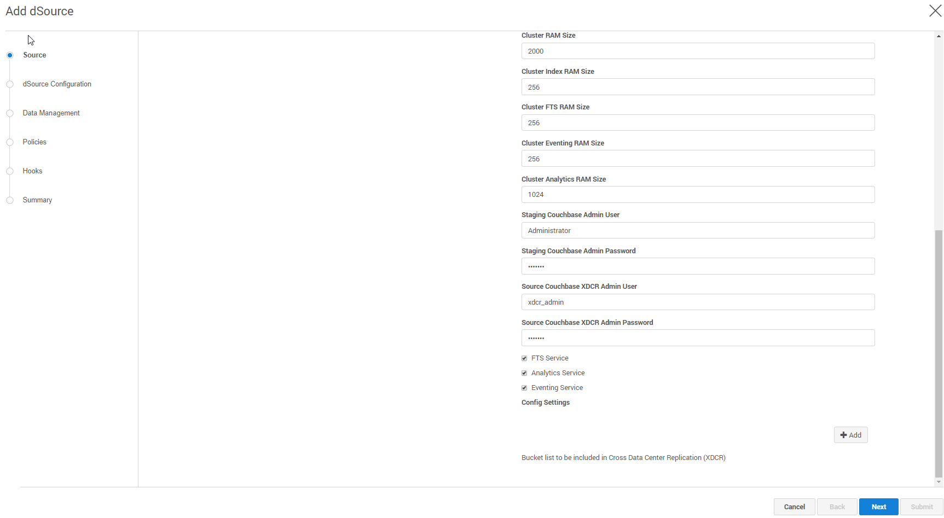

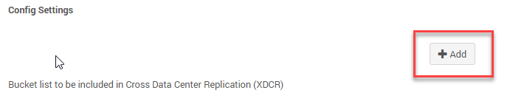

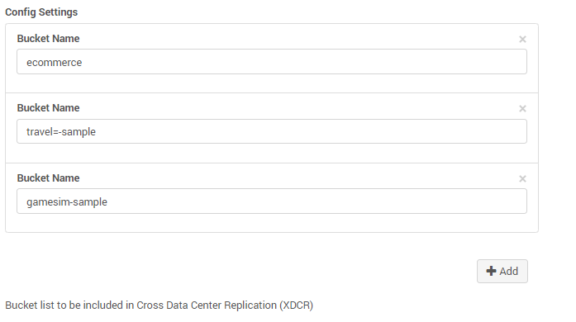

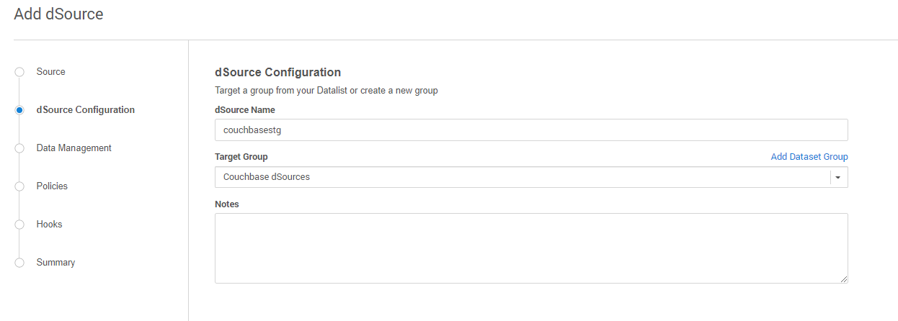

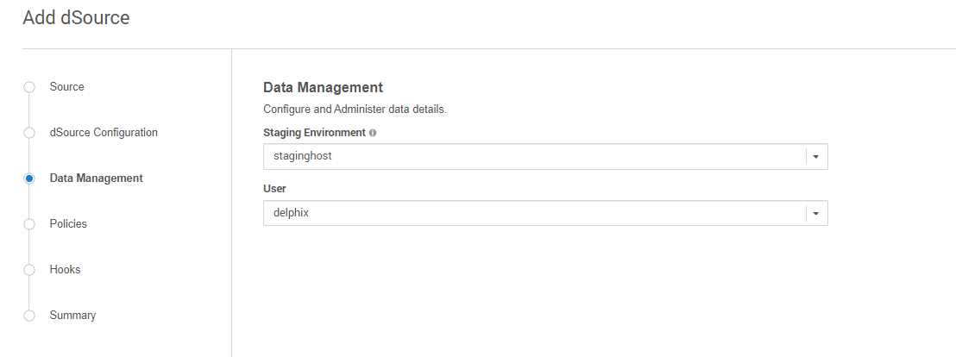

Complete the wizard and click submit.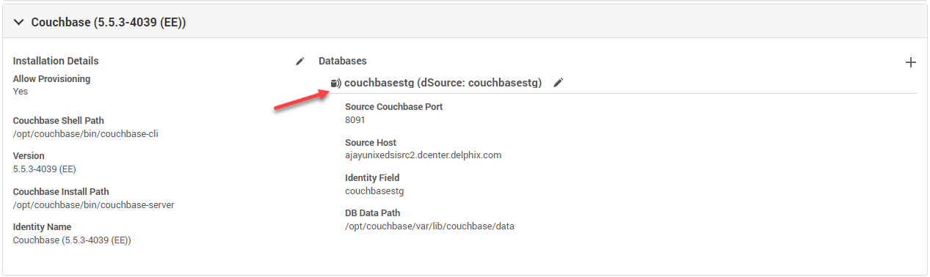

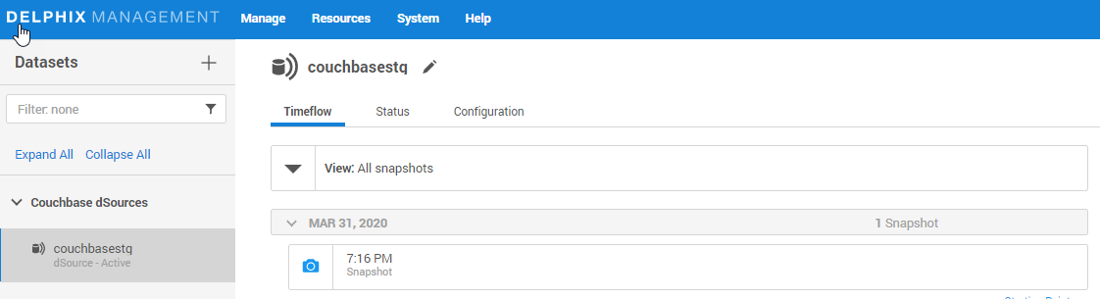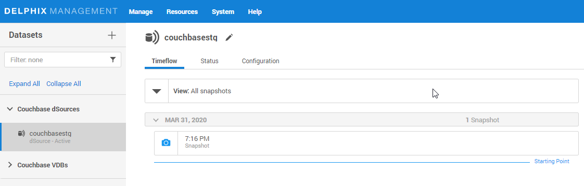

## Couchbase Backup Manager Method

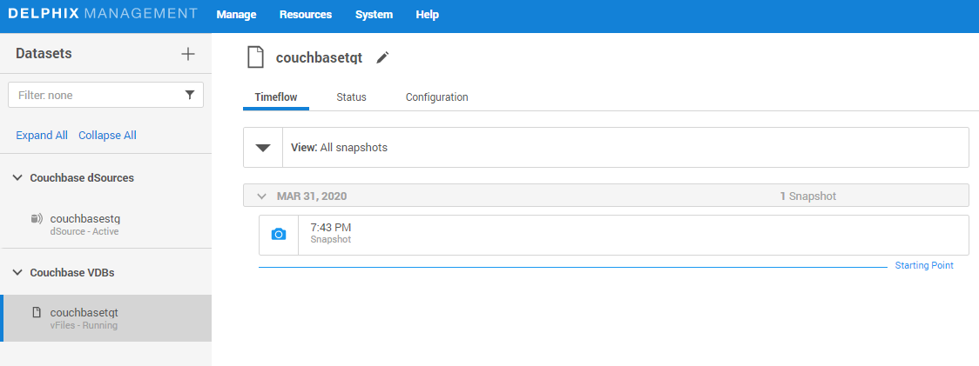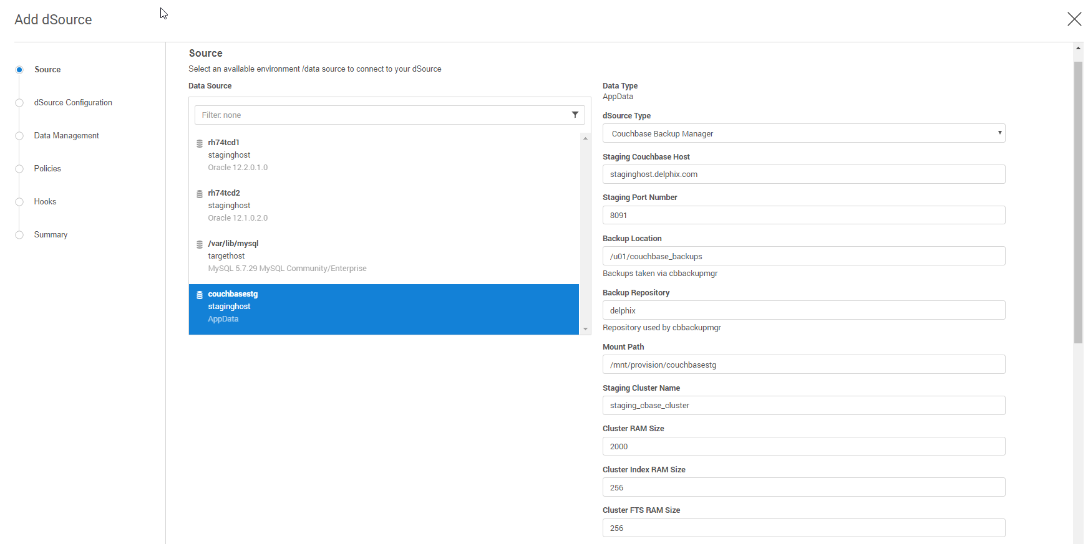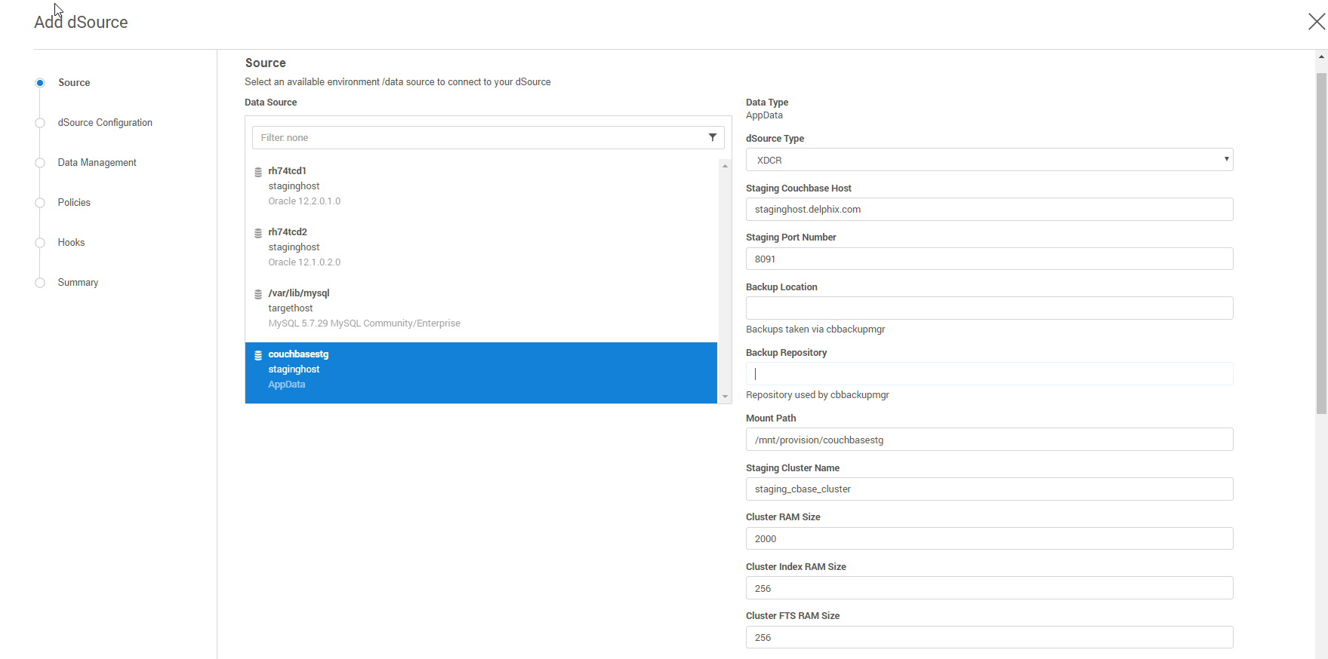

# Provision VDB

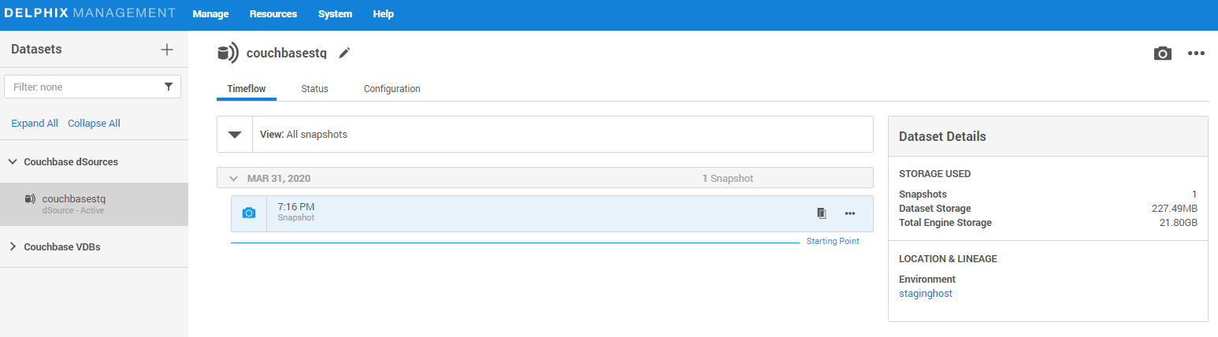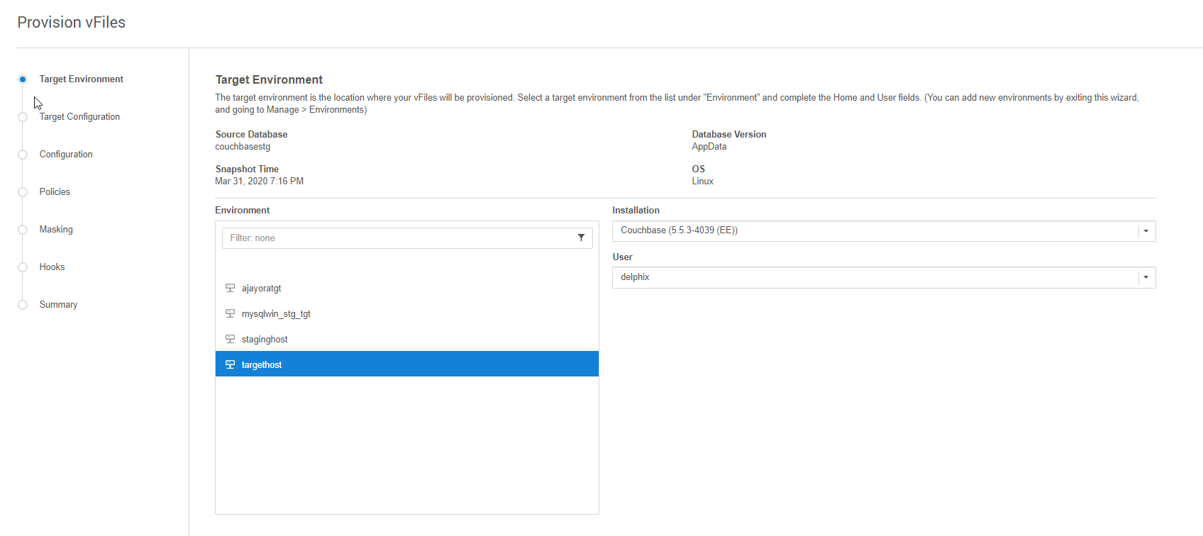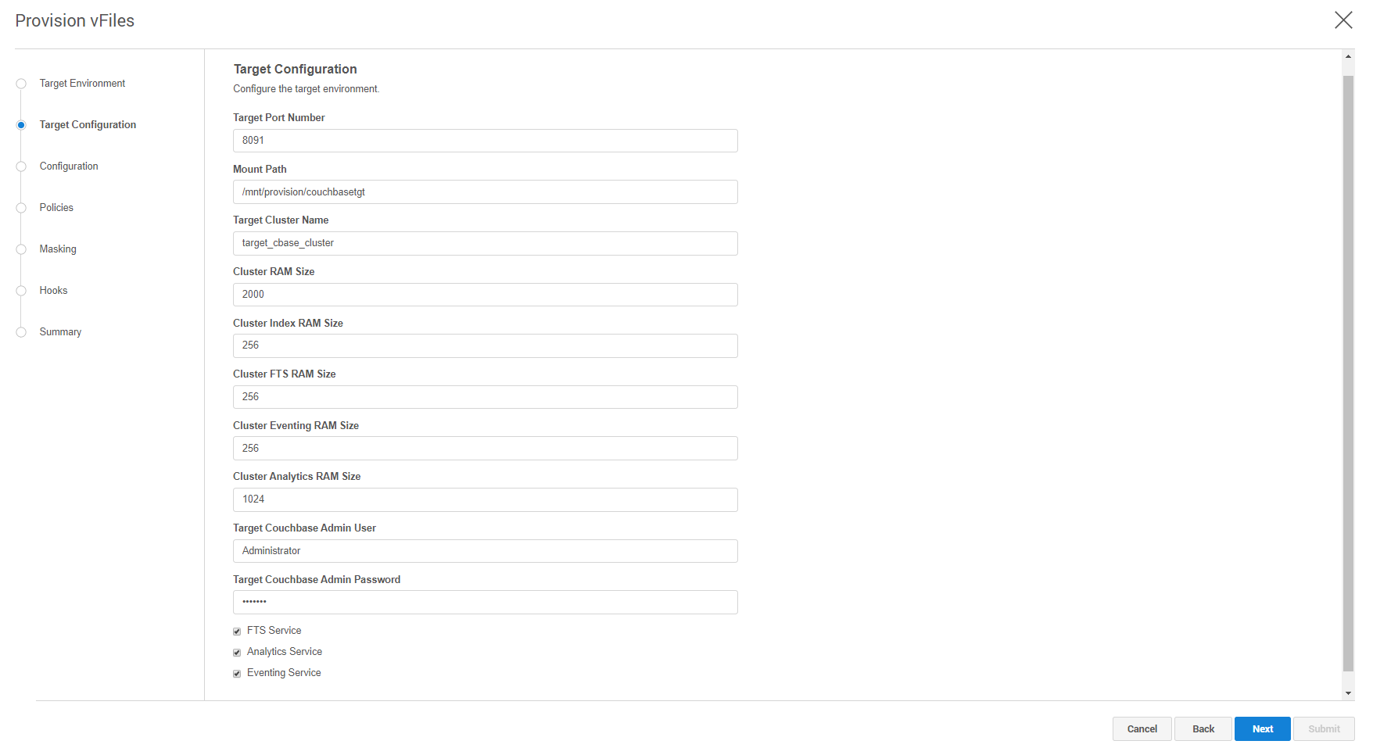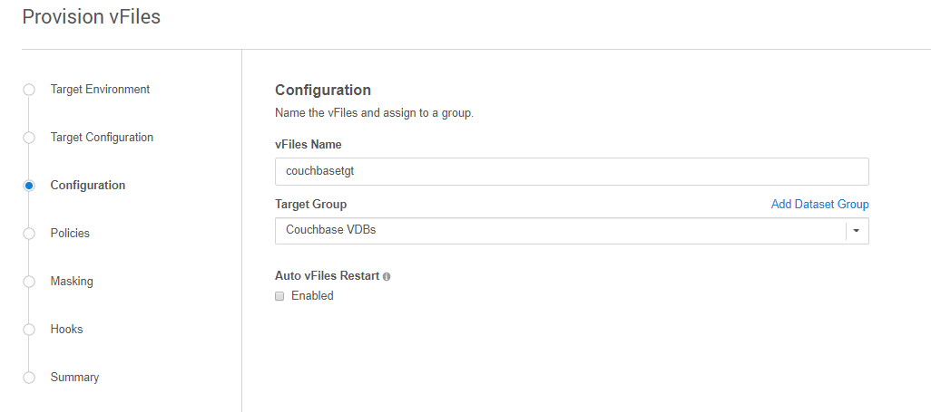

# Appendix

## Known Issues

### Simultaneous dSource creation

